# Scratch logo and symbol, meaning, history, PNG

**Scratch Invaders 5**

Register/login at <https://scratch.mit.edu>

*Flying Saucer attack! The saucer flies across the top of the screen dropping targeted bombs.*

1. **Download *invader* images from:  
   <https://codeclub67.github.io/images/invader.gif>
2. Create a new **saucer** sprite from the *invader* images, and select the saucer costume.
3. 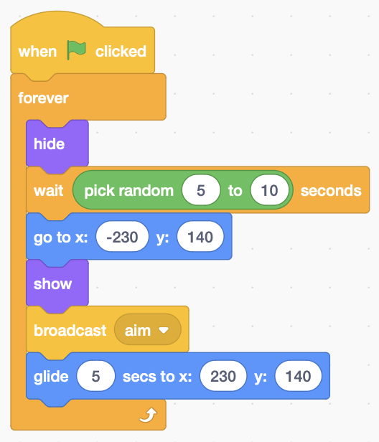Add code to the **saucer** that **waits** a random time before appearing. It appears at the left of the screen and **glides** to the right. It also **broadcasts** a message to take **aim**.
4. 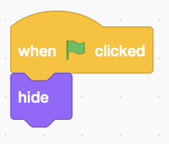Create a **drone** sprite (the saucer’s targetted bomb), using the same costume as the invader bomb.
5. Add code to the **drone** that hides it at the start of the game.
6. Add **drone** code that receives the message to take **aim**, then **waits** until the saucer reaches the x position of the cannon before dropping   
   (see over page).
7. 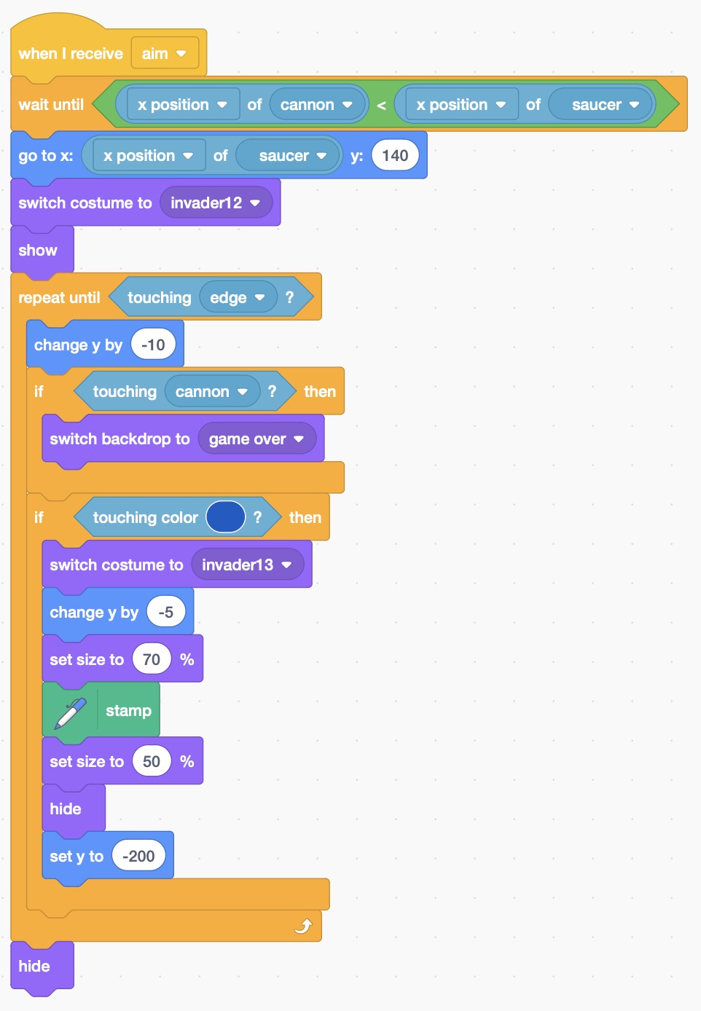If the drone **touches** the cannon the game’s over.

*The drone can see the x position of the  
cannon, and compares it with the x position   
of the saucer. The* ***drone*** *falls steadily, reducing y by -10 each time round the loop.*

1. 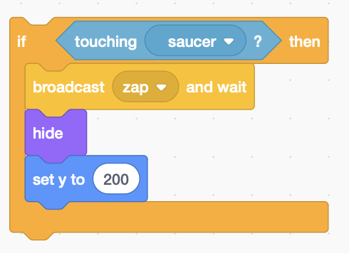If it **touches** the shields, it blasts a hole in them.

*It must be possible to destroy the saucer!*

1. *Add code to the* ***missile*** *loop to sense contact with the saucer, and* ***zap*** *it!*
2. 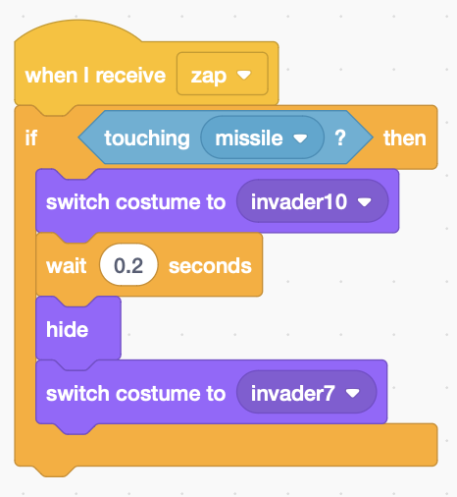If the **drone** gets zapped and it’s **touching** the missile then it explodes like a regular invader.

***Save*** *your code.*